Vulnerability Scan: Tools to Identify Vulnerability Scan.

Vincent Kiweesi

Capstone

May 23rd, 2023

The technique of vulnerability scanning is important for locating weak points in a network or system. A vulnerability scanner is a tool used to find well-known security flaws in applications, operating systems, and network hardware. The methods and technologies that can be utilized for vulnerability scanning will be covered in this page descrIPtion.

Tools and Methods:

Tenable Nessus One of the most often used tools for checking vulnerabilities among security experts. Numerous operating systems, databases, apps, and virtualized environments can all be scanned. Based on the severity of the vulnerabilities, Nessus can identify and prioritize them. On Windows, Linux, or macOS operating systems, Nessus can be installed. Installing the Nessus scanner is required before creating a scan policy that specifies the kind of scan we want to run. To include or exclude specific hosts, ports, and protocols, the policy can be altered. The scans can be set to run at predetermined times. Nessus will produce a report detailing any vulnerabilities it discovers. (Tech2020, 2021)

**Pros:** Nessus is simple to use and offers a thorough list of vulnerabilities. Additionally, it offers a big library of plugins that may identify different kinds of vulnerabilities.   
  
**Cons:** Nessus can be costly, and it might generate a lot of false positives.

Methods used to scan for open ports scanning in Nessus:

* A scan run on local host and discovered vulnerability as shown in the screen shots
* Performed a local host IP address look up using the command curl ifconfig.me

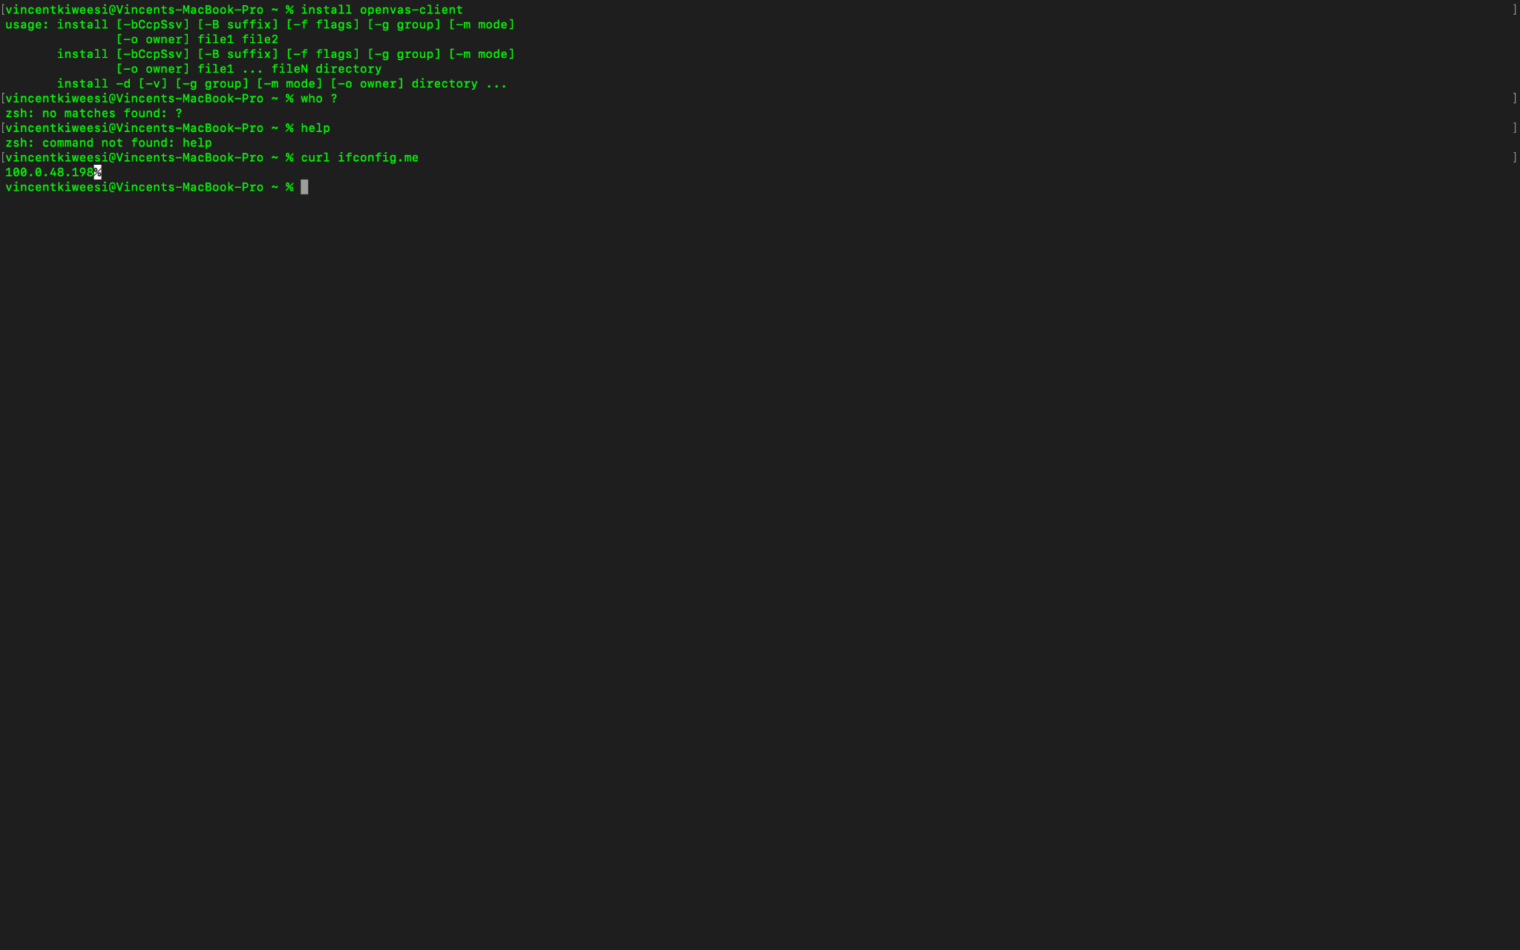

* Here click on new scan.

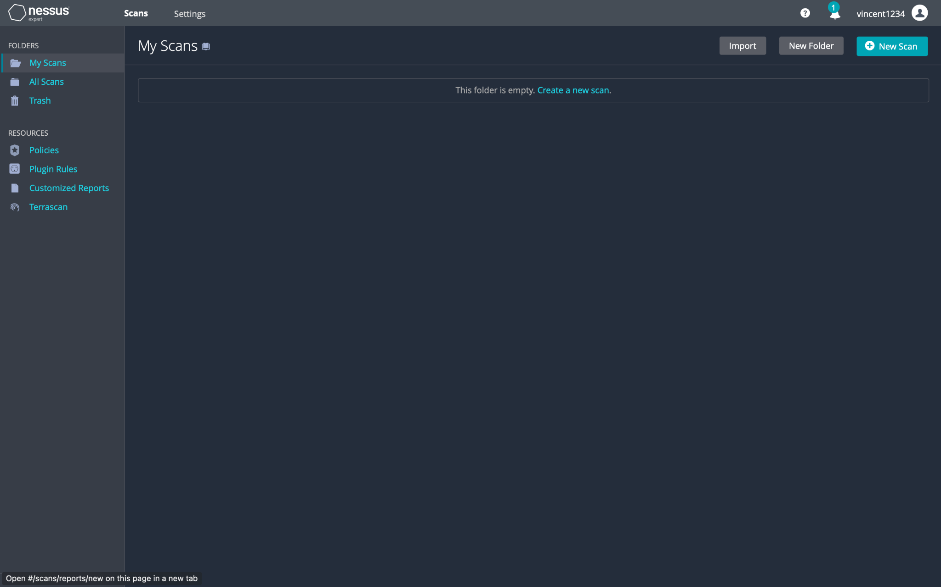

* Utilize simple scan to discover vulnerabilities.

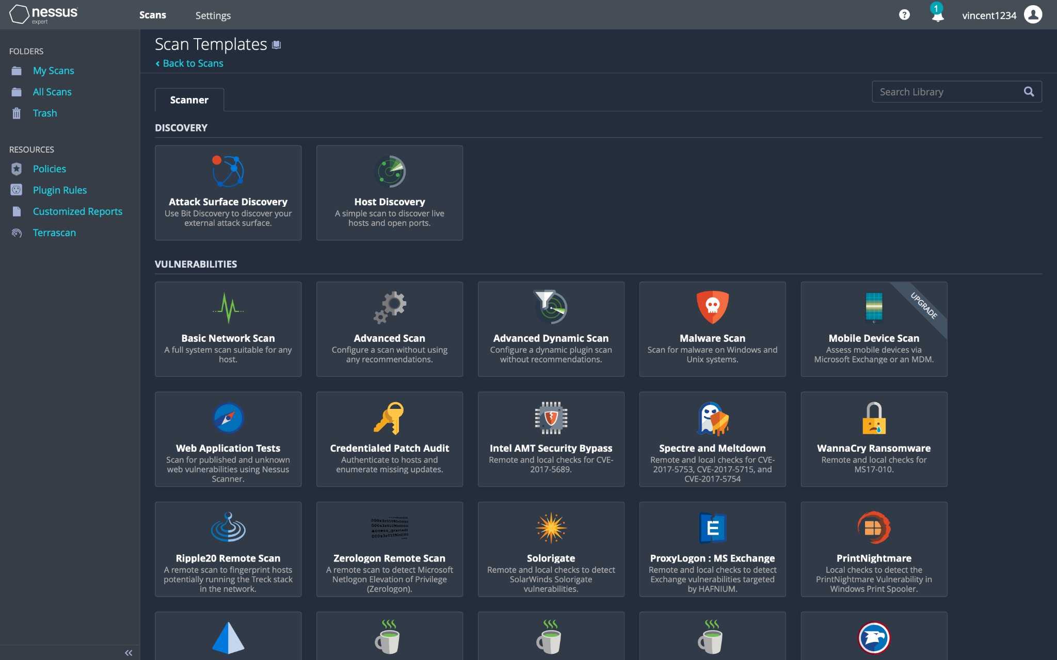

* Configured the scan and added the local host IP address as the target, saved, and run the scan.

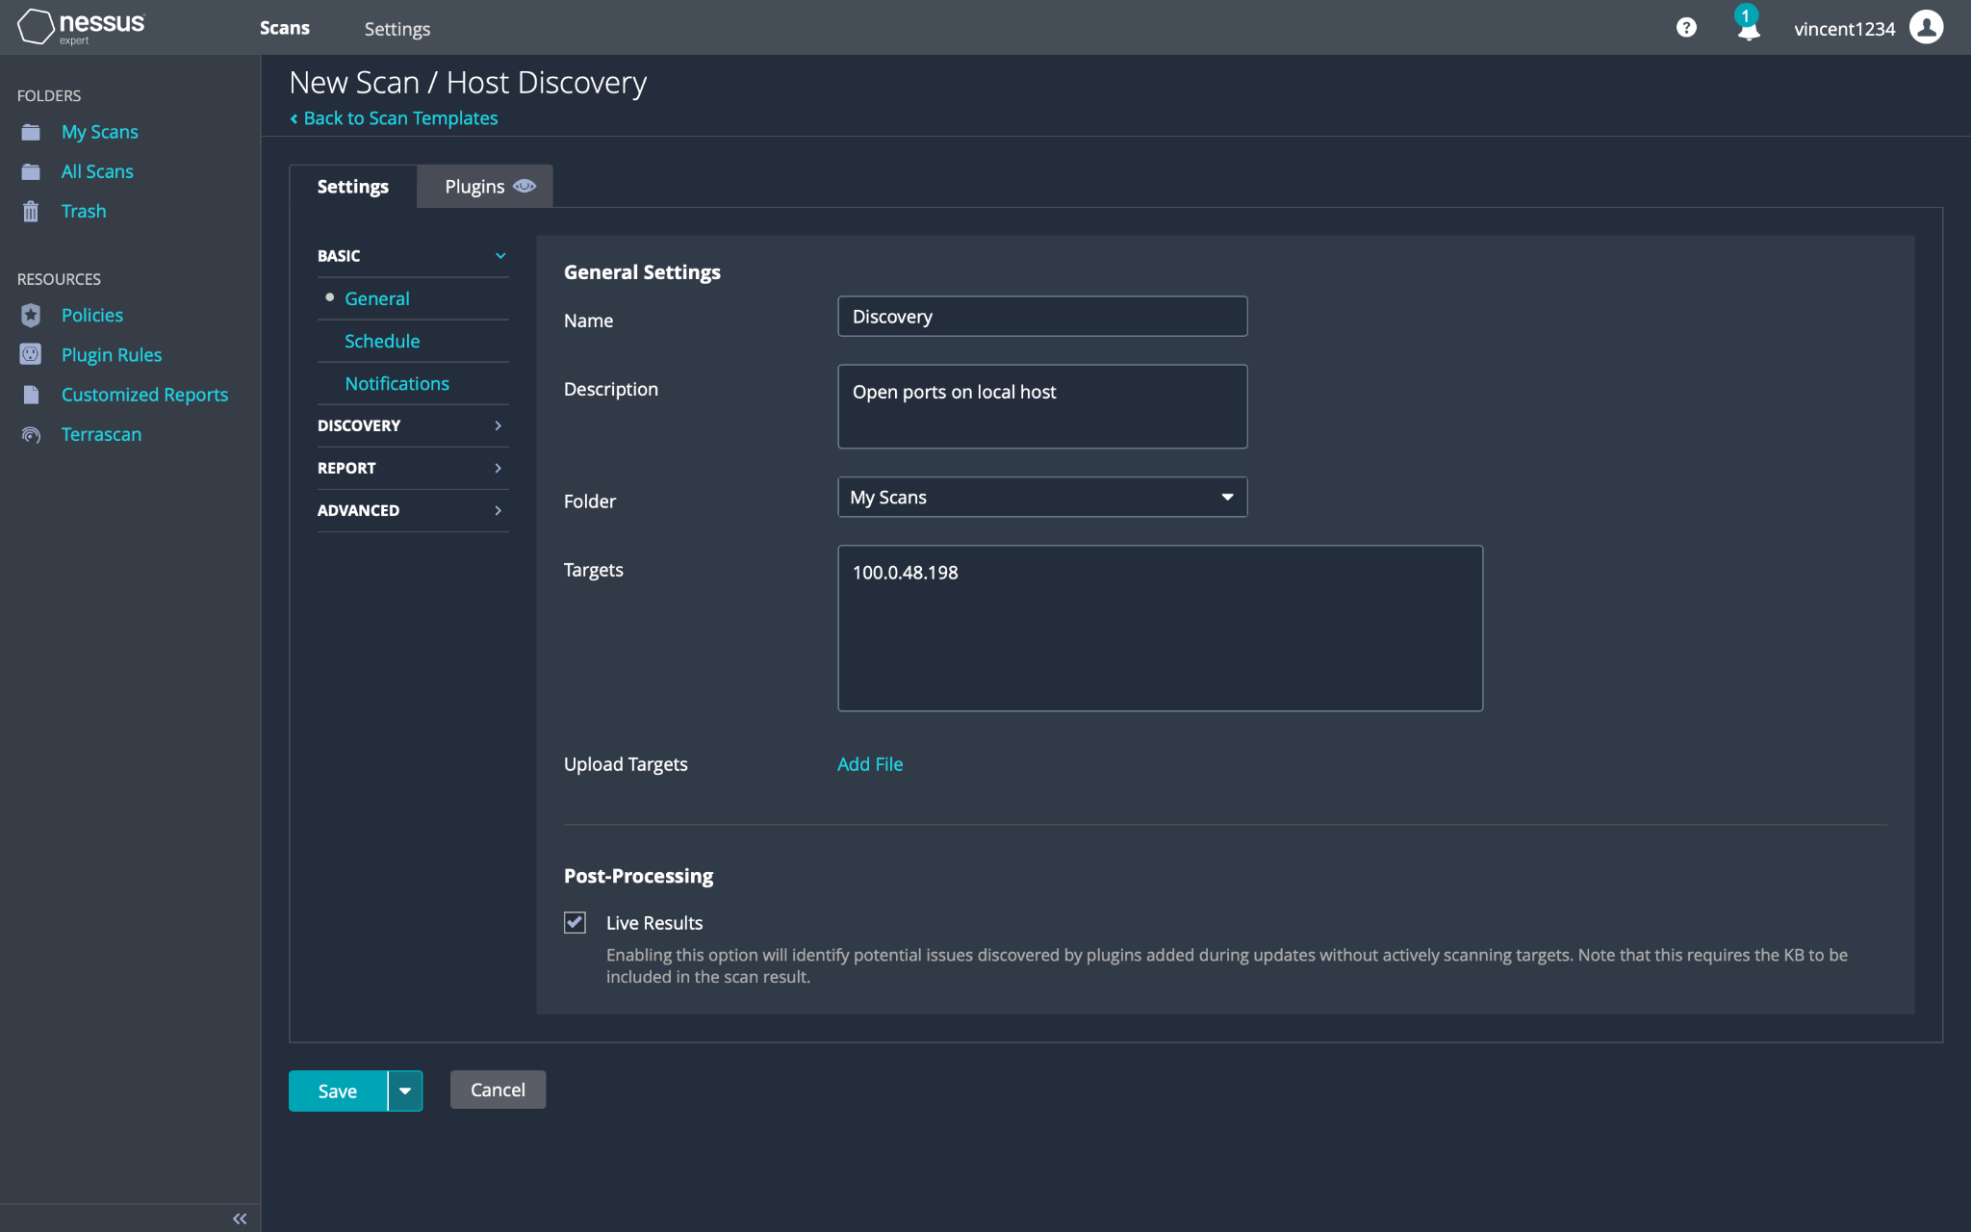

* Two vulnerabilities were discovered after completing the scan successfully.

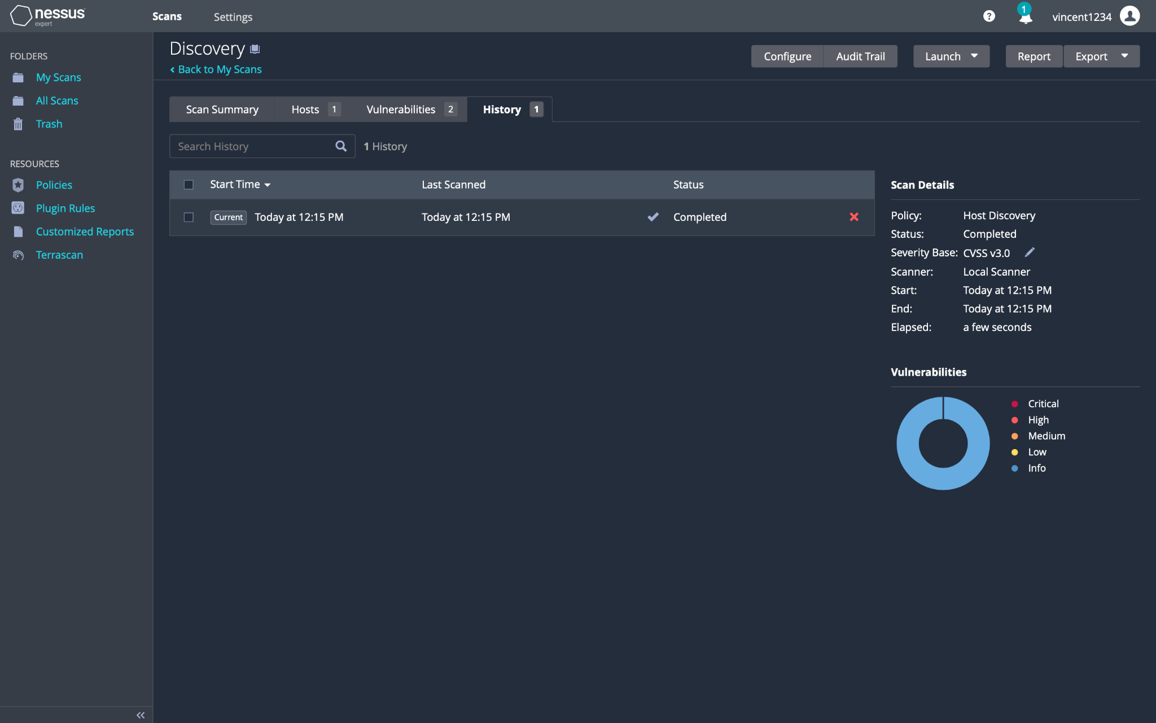

* Below is the descrIPtion of the vulnerabilities.

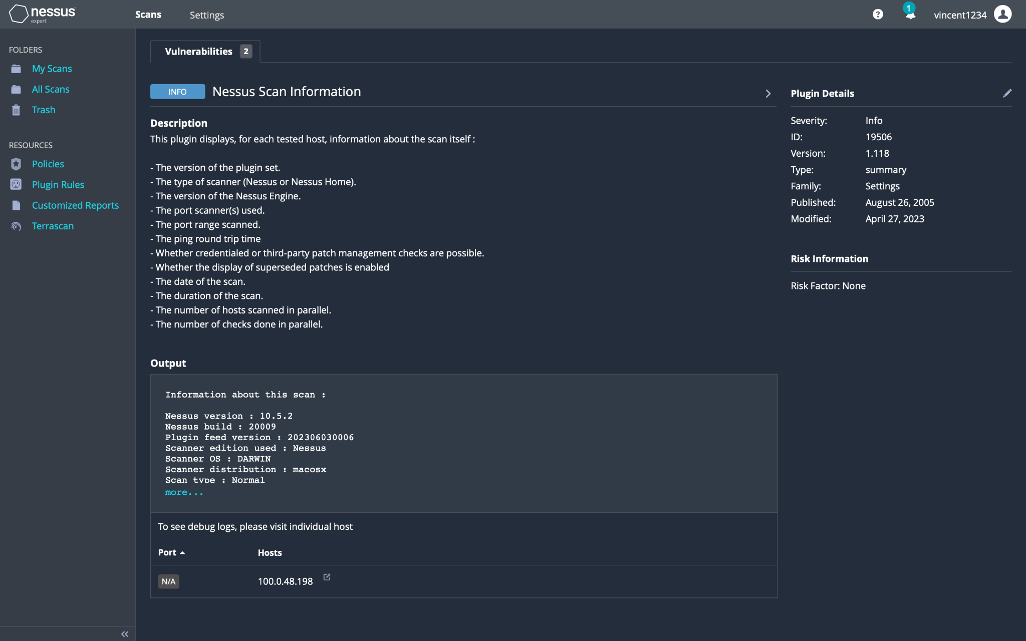

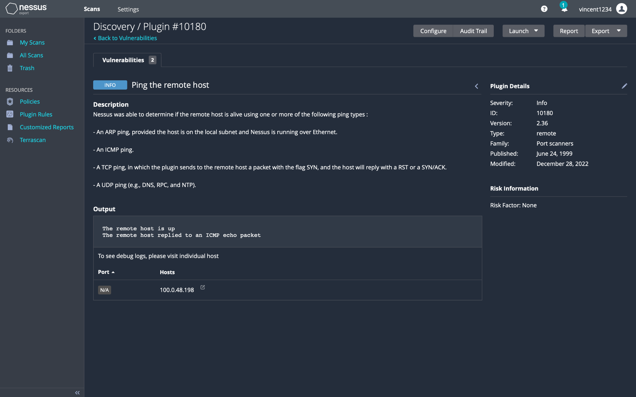

* This is the scan summary.

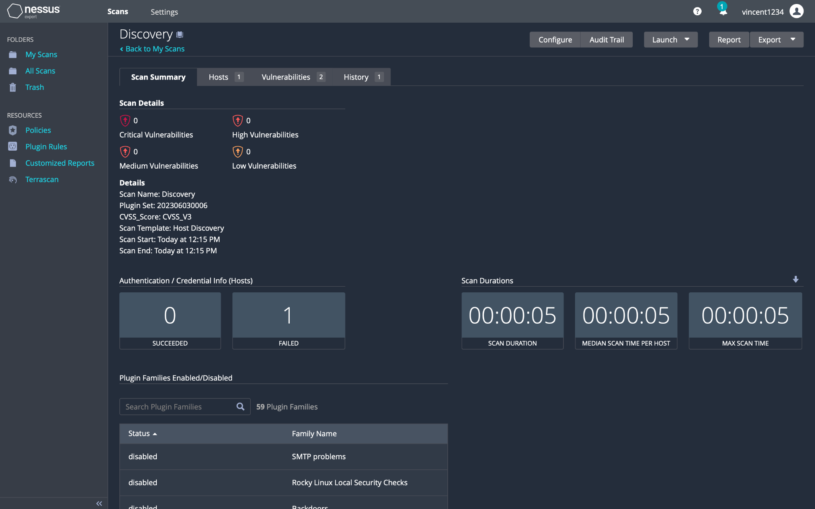

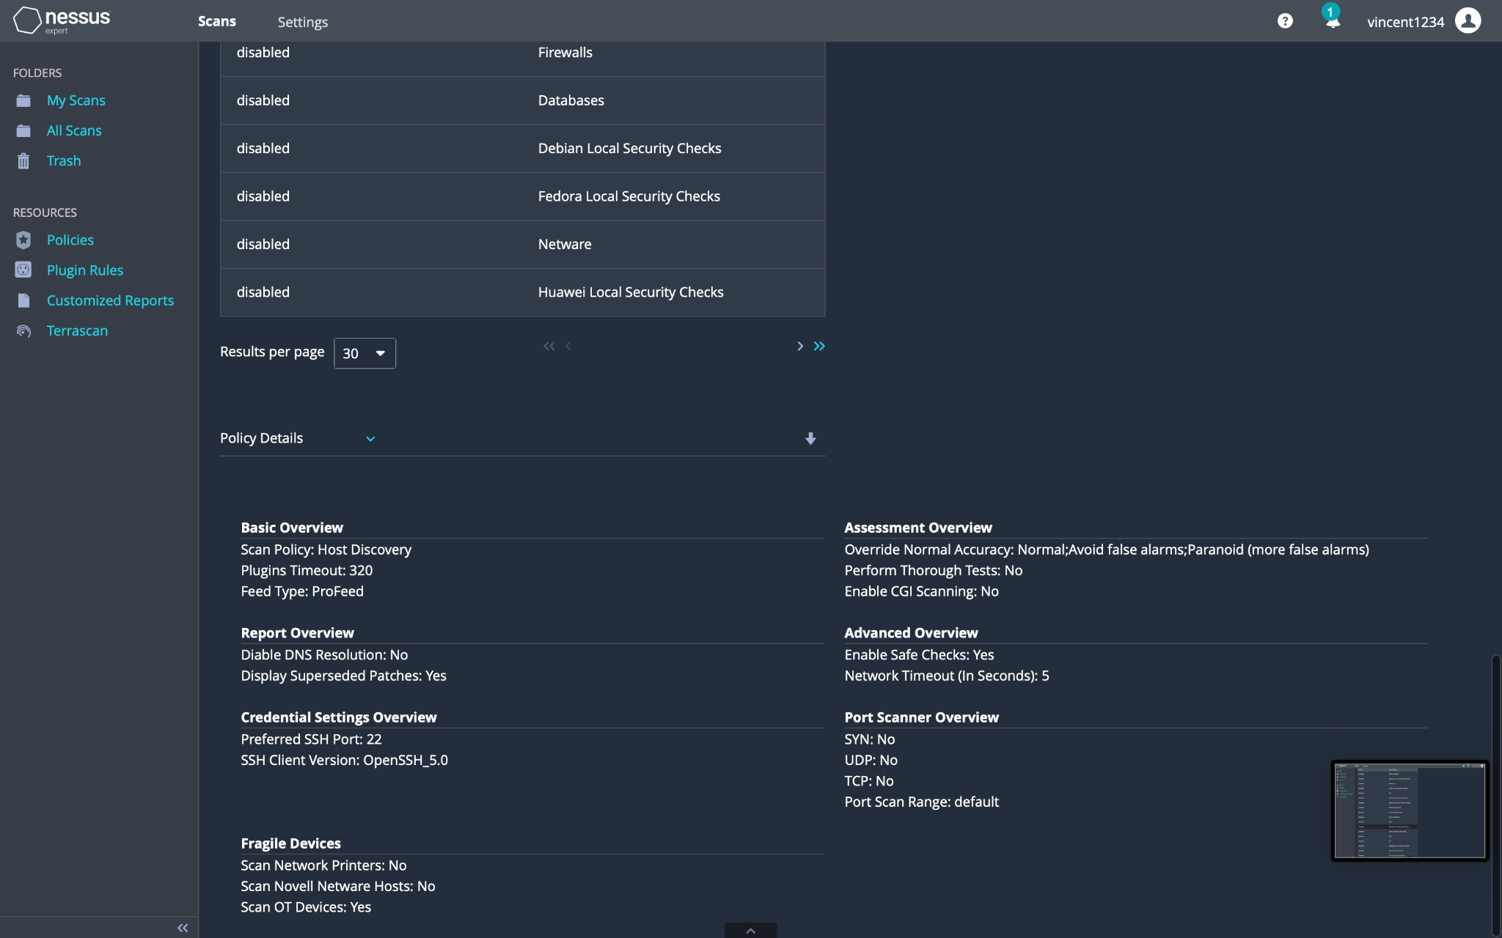

An open-source vulnerability scanning tool called OpenVAS can find known hosts' and networks' vulnerabilities. MultIPle operating systems, databases, and applications can be scanned by OpenVAS. Linux and Unix operating systems both support the installation of OpenVAS. We must install the OpenVAS server and client to use OpenVAS. The types of scans we want to run can then be defined by configuring the scan policies. The scans can be set to run at scheduled times. A report of the vulnerabilities found by OpenVAS will be produced (20 et al., 2021).  
  
**Pros:** OpenVAS can find several kinds of vulnerabilities and is free open source. It also includes a big library of plugins.   
  
**Cons:** OpenVAS could generate a lot of false positives. To utilize it efficiently, one might also need to have advanced technical knowledge.

**Methods**

* Performed a local host IP address look up using the command curl ifconfig.me.



* Utilize a quick scan by clicking on the magic wand looking icon then type in the local host IP address of the mac os.

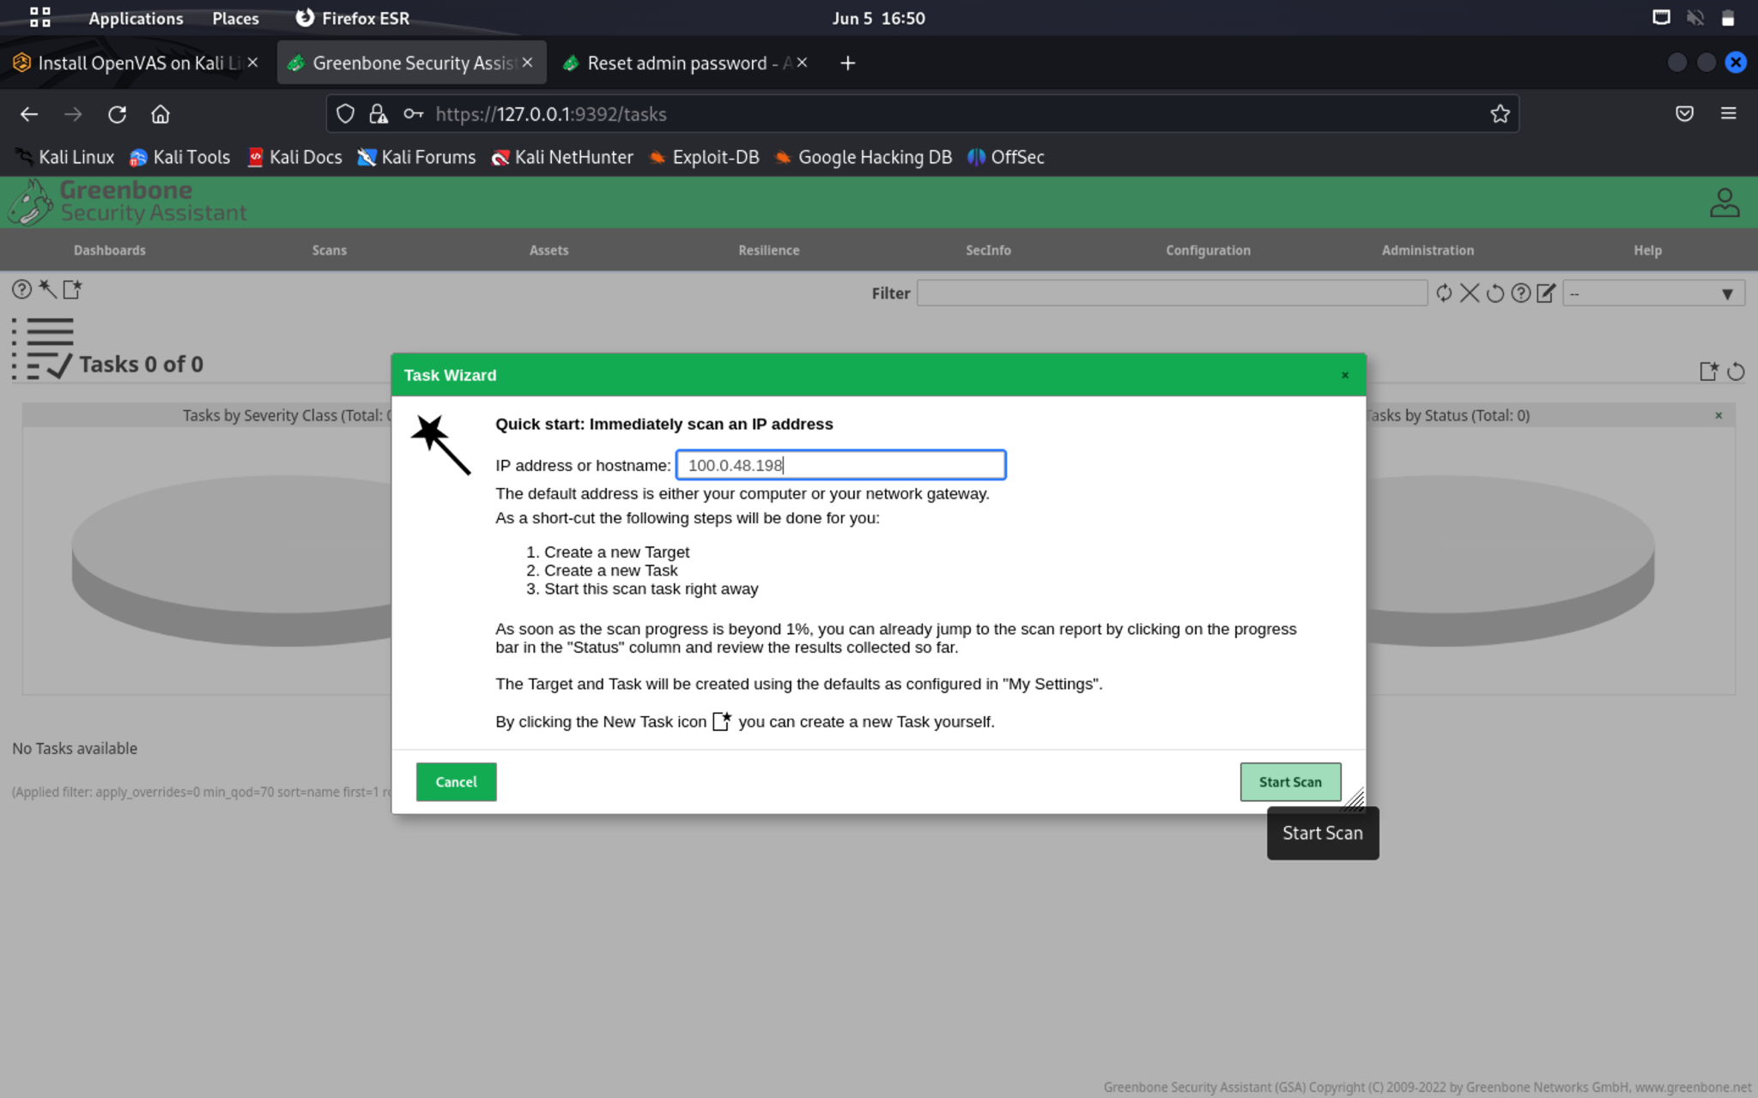

* From scans click on task page to view my activity conduct from the previous immediate scan of IP 100.0.48.198

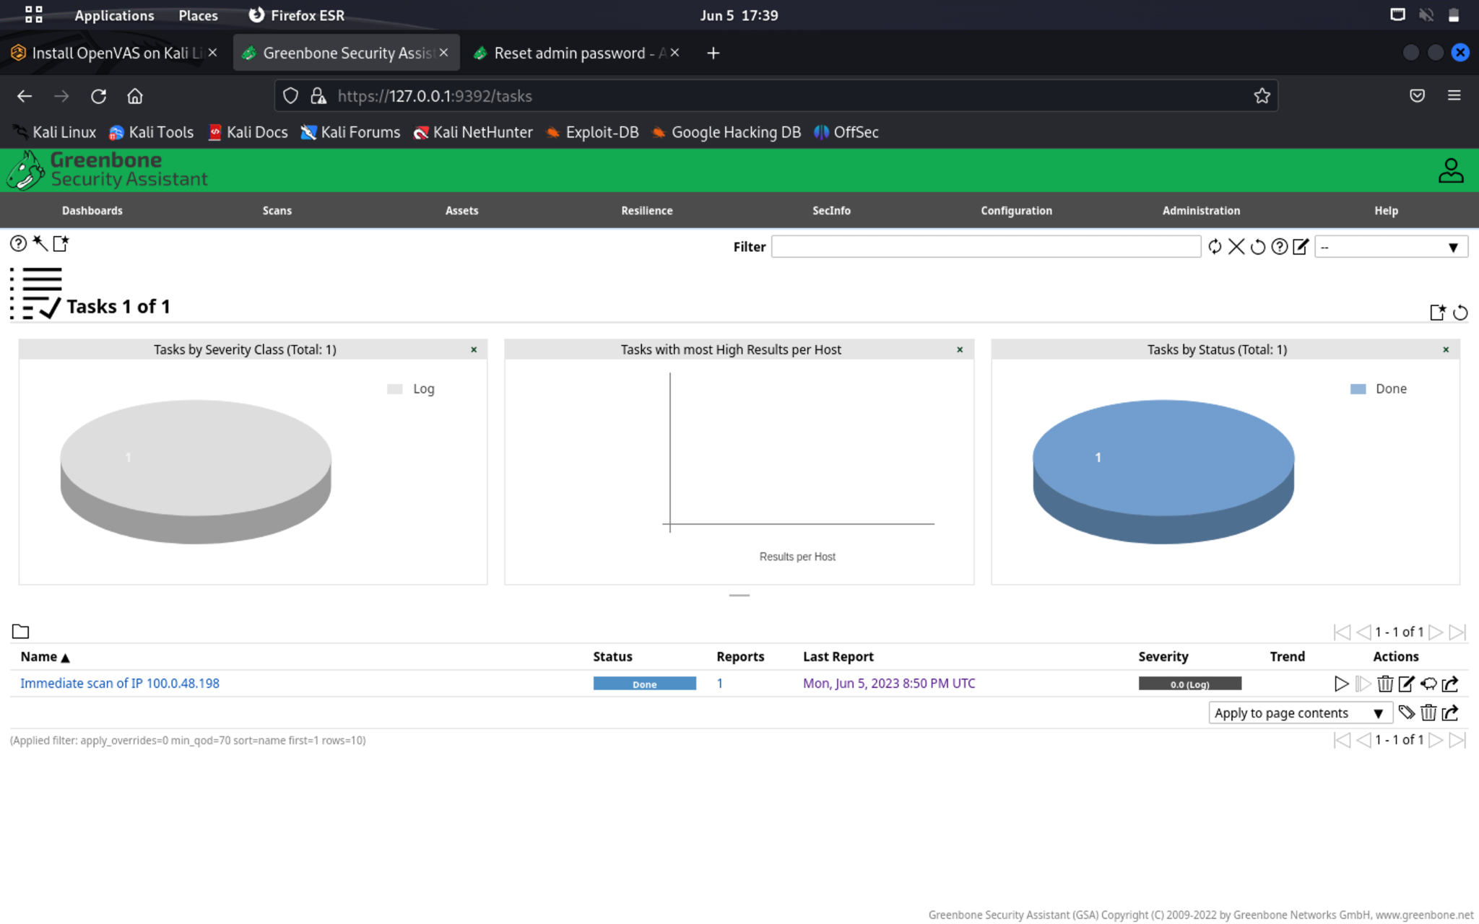

* After click the last report from the task page to see a full scan report and identify things like vulnerabilities, hosts, ports, and operating system.

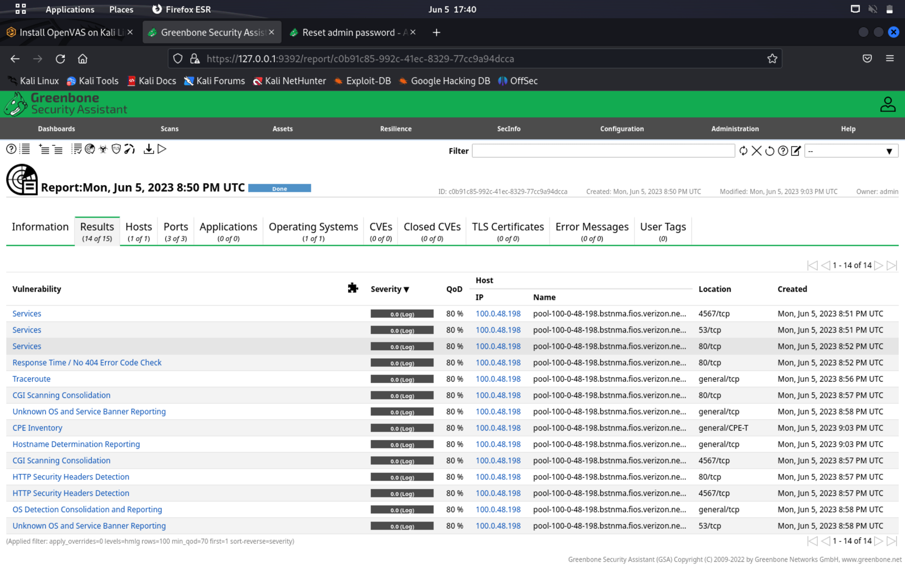

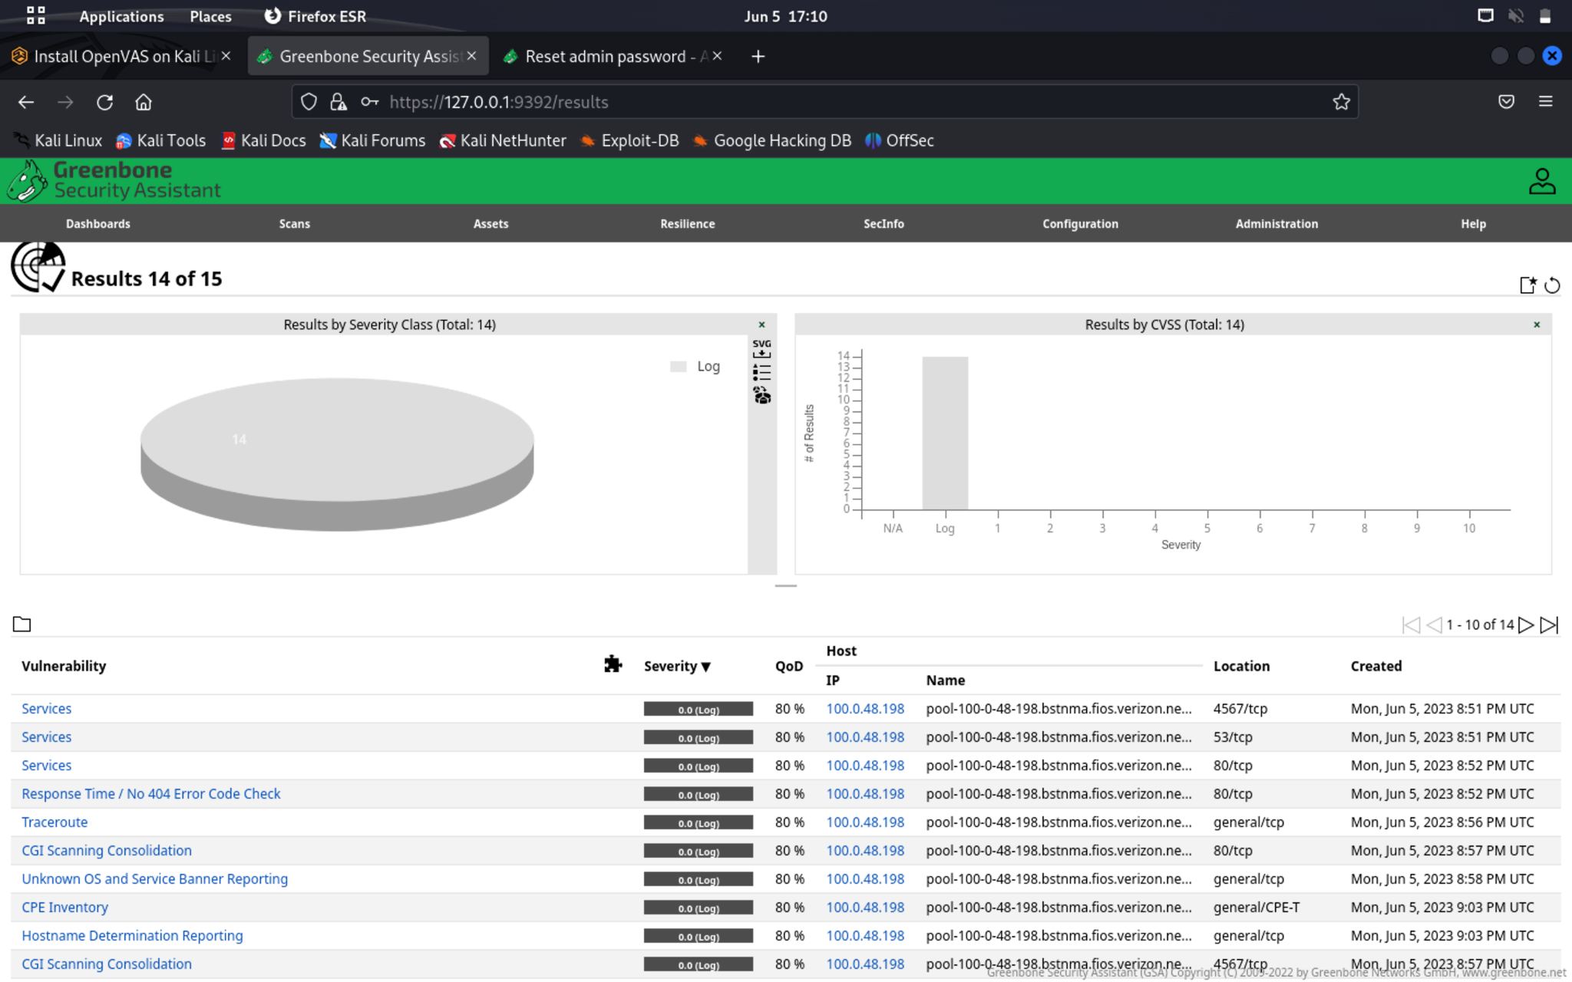

Nmap is a network auditing and security tool. On a network, it can find open ports, services, and operating systems. Network device vulnerabilities can also be found with Nmap. On Windows, Linux, or macOS operating systems, Nmap can be installed. We must provide the IP addresses of the hosts we wish to scan in order to use Nmap. The type of scan we wish to run can then be specified by configuring the scan settings. The hosts and vulnerabilities that Nmap finds will be listed in a report (Shivanandhan, 2020).

**Pros:** Nmap is a free and open-source vulnerability scanner that can find many kinds of flaws. Also, it is simple to use.

**Cons:** Nmap could provide a lot of false positive results. It might also need advanced technical knowledge to use.

Methods used to conduct a scan on Nmap.

* Clicked the applications menu, move to vulnerability analysis ,and then to the right click Nmap to open up in the terminal.

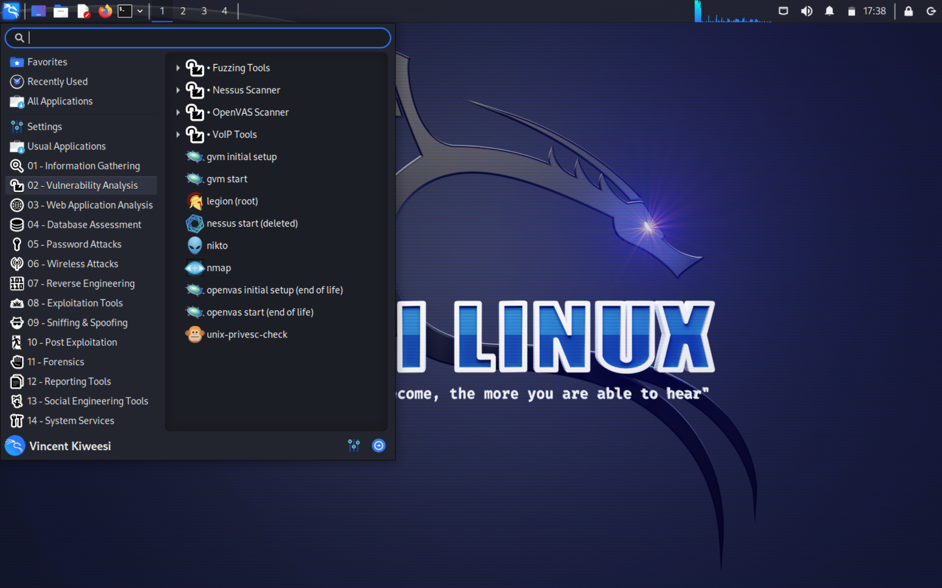

* Typed in 100.0.48.198 for open ports on the mac os local host using kali virtual machine installed.

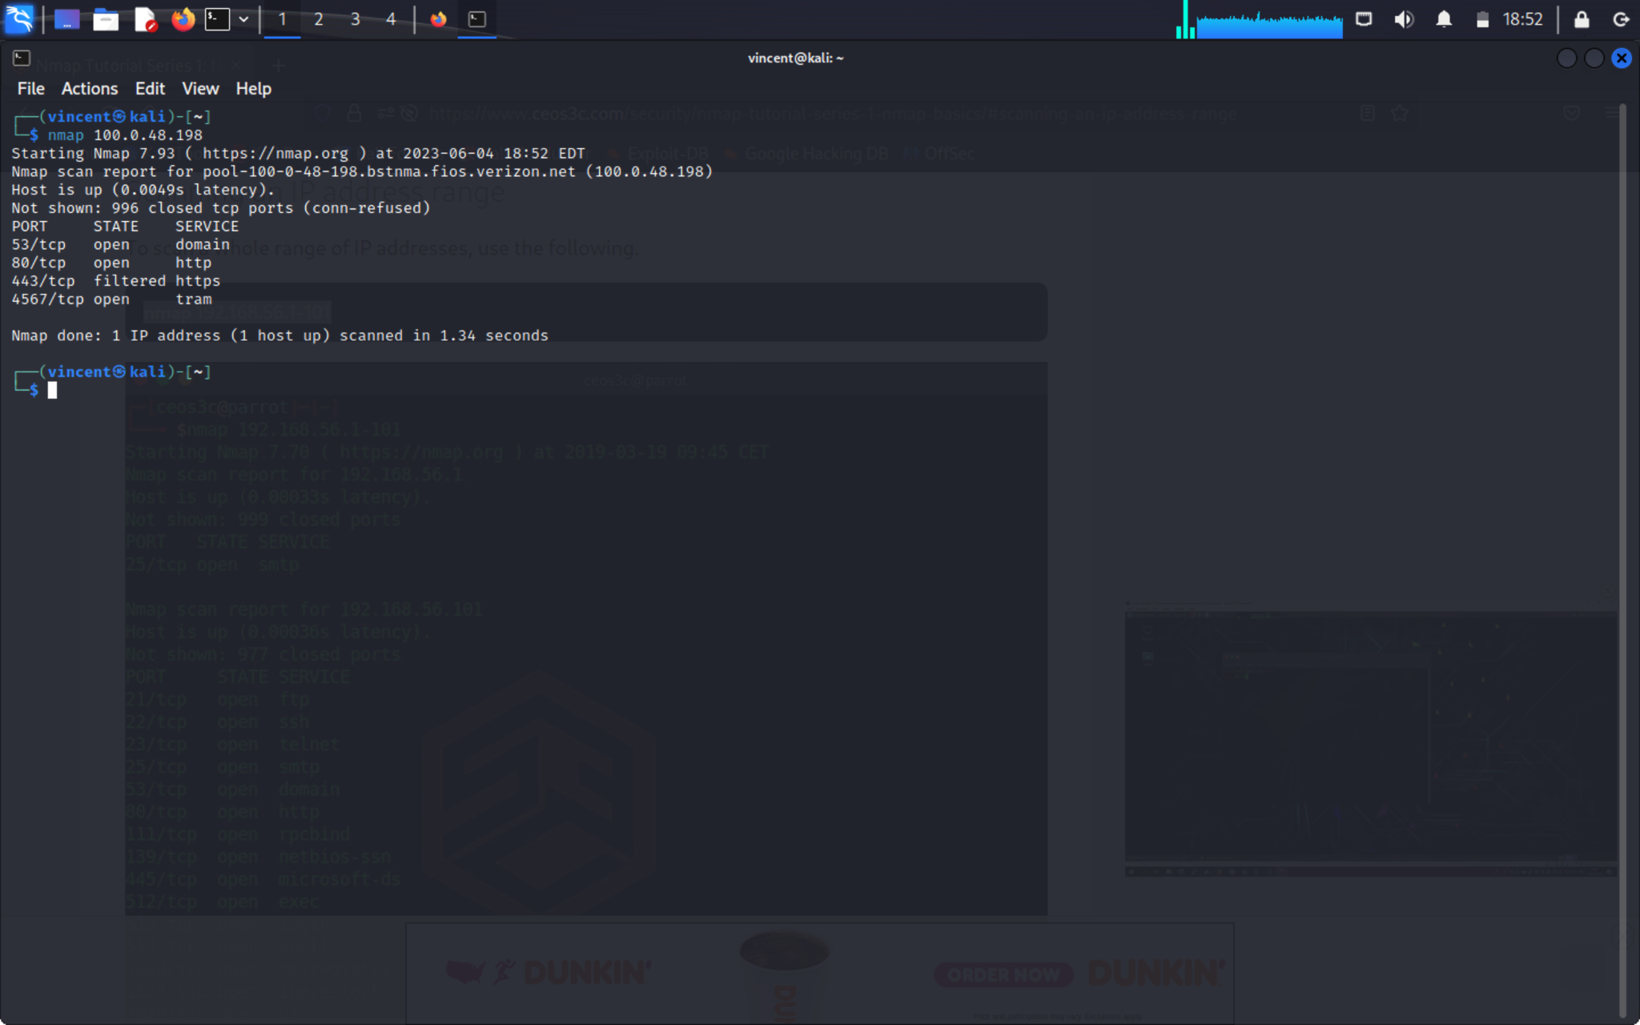

A web server scanner called Nikto can find vulnerabilities in online applications. Web servers and web applications can contain known vulnerabilities that Nikto can identify. On Windows, Linux, or macOS operating systems, Nikto can be installed. We must provide the URL of the web application we wish to scan to use Nikto. The type of scan we wish to run can then be specified by configuring the scan settings. A report of the vulnerabilities found by Nikto will be produced.   
  
**Pros:** Nikto can find many kinds of vulnerabilities in web apps and is free and open source.   
  
**Cons:** Nikto could generate a lot of false positives. To use it efficiently, one might also need to have advanced technical knowledge (Marasinghe, 2022).

* Performed a local host Ip address look up using the command curl ifconfig.me.



* Click the applications menu, move to vulnerability analysis ,and then to the right click nikto to open up in the terminal.



* Run a scan targeting port 80 of mac os local host IP 100.0.48.198 on kali linux virtual machine.

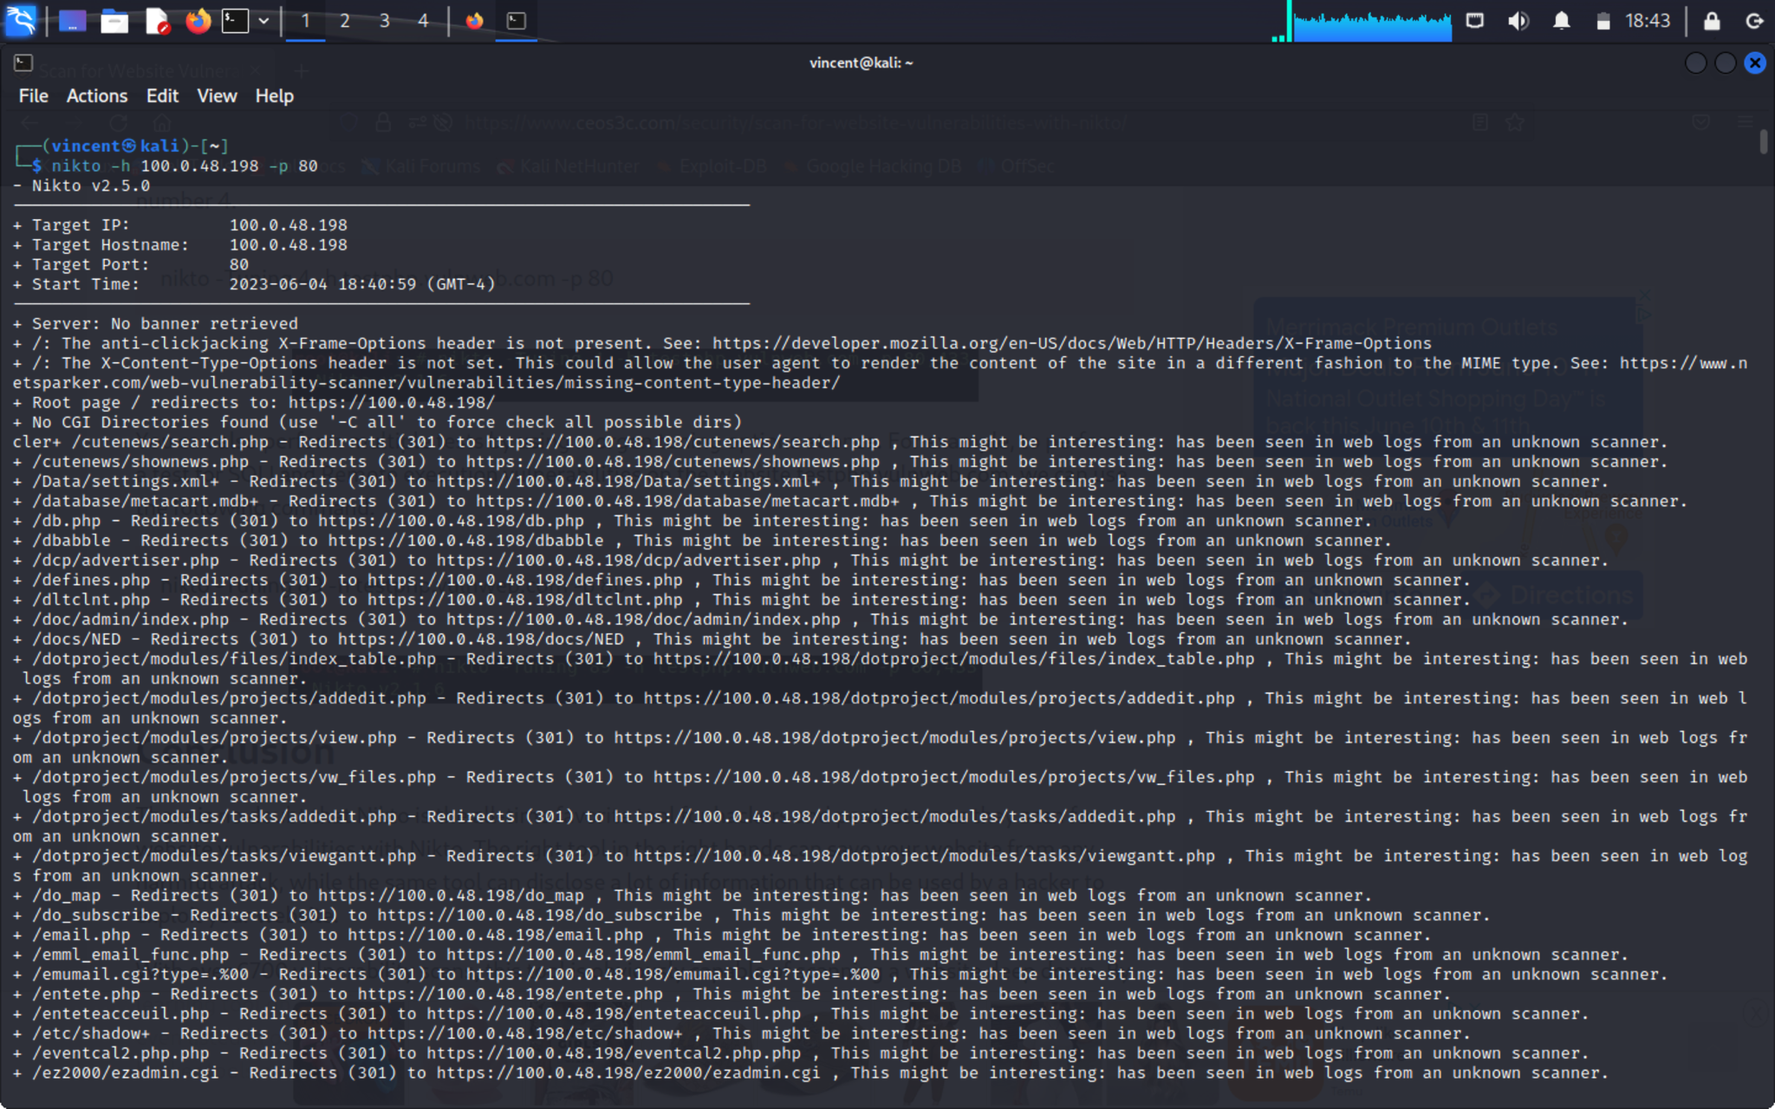

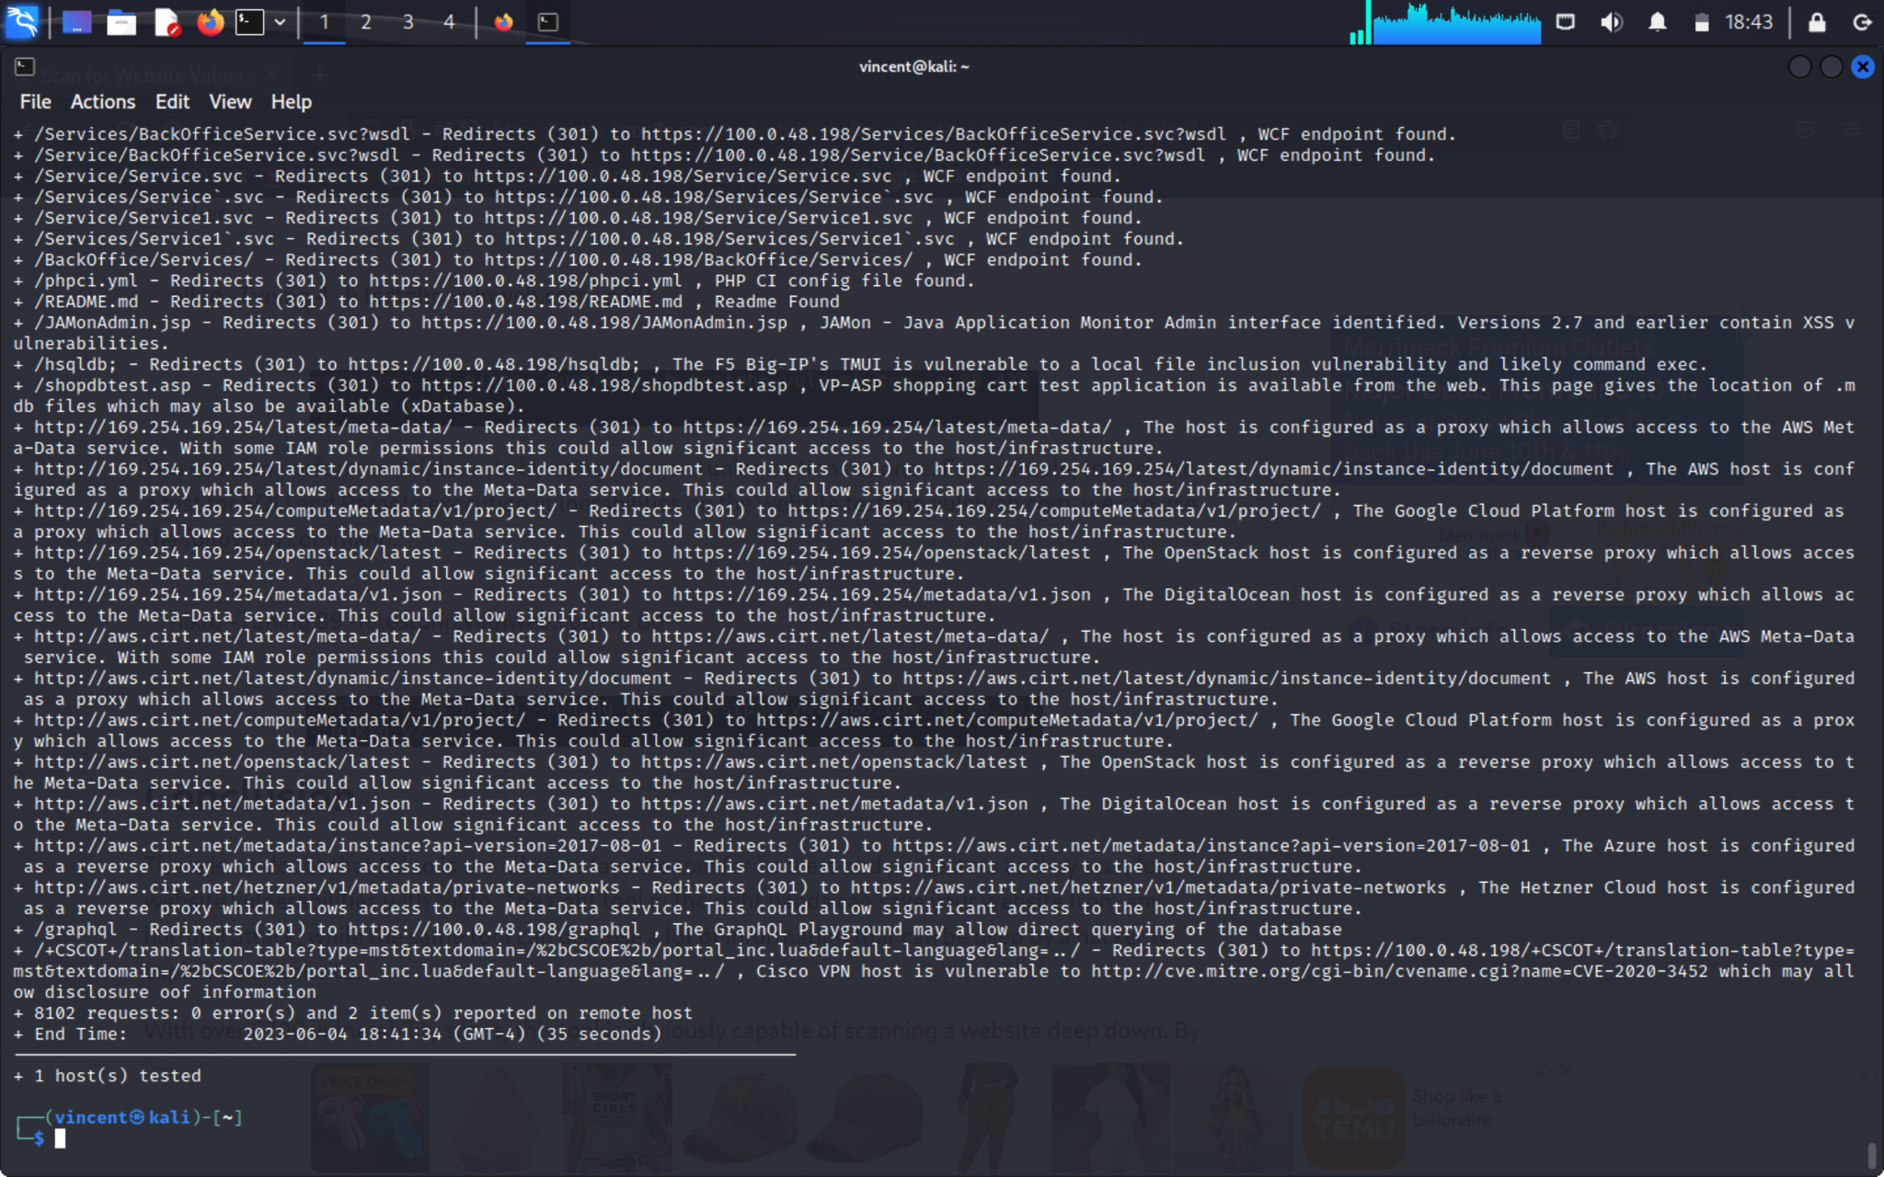

Qualys. A solid approach to cybersecurity risk identification, assessment, detection, and response. A robust risk-based vulnerability management solution is provided by Qualys VMDR that allows users to rank assets and vulnerabilities according to risk and business criticality. To efficiently identify, prioritize, and automatically fix vulnerabilities at scale to lower risk, VMDR interfaces easily with configuration management databases (CMDB) and patch management programs. It also incorporates ITSM programs like ServiceNow to fully automate and operationalize vulnerability management.  
Get a risk-based vulnerability management solution that is all-inclusive, prioritizes assets, misconfigurations, and vulnerabilities based on risk, reduces risk by patching vulnerabilities at scale, and enables companies to analyze risk reduction over time to assess the success of their security programs (Qualys VMDR - Vulnerability Management Tool n.d).

**Pros:**

Qualys has many options and powerful tools which increase the security of a system are one of the key aspects of this program that I appreciate.  
  
The Qualys Cloud Platform is an excellent tool that enables all of its customers to monitor each web process while abiding by the laws and exploiting the least risky apps.  
  
All of my online business activities are now completely safe thanks to the assistance of this program; Qualys Cloud Platform will take care of preventing all online attacks.

**Cons:**

The many features that are provided to us are not very obvious, and in some situations, it requires intuition to carry out a function. This application is also not very instructive also will need someone with advanced knowledge of the field.

**Methods used:**

* From the web application select web application creation as shown in the image with the target as www.springboard.com and named the scan umass Global.

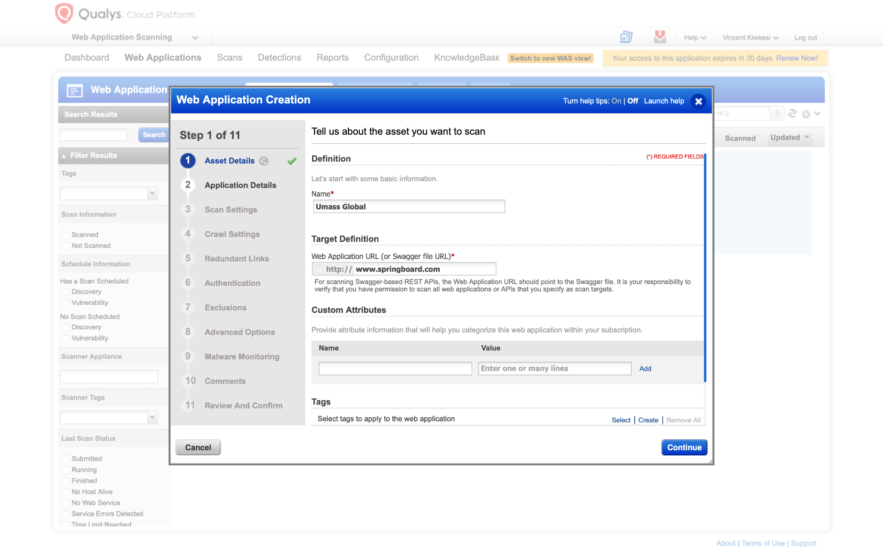

* From the web application scanning menu click new scan then prompted to create a scan name ( web application vulnerability scan -2023006-05) selected umass Global as asset to scan then run the scan after configuring the target.

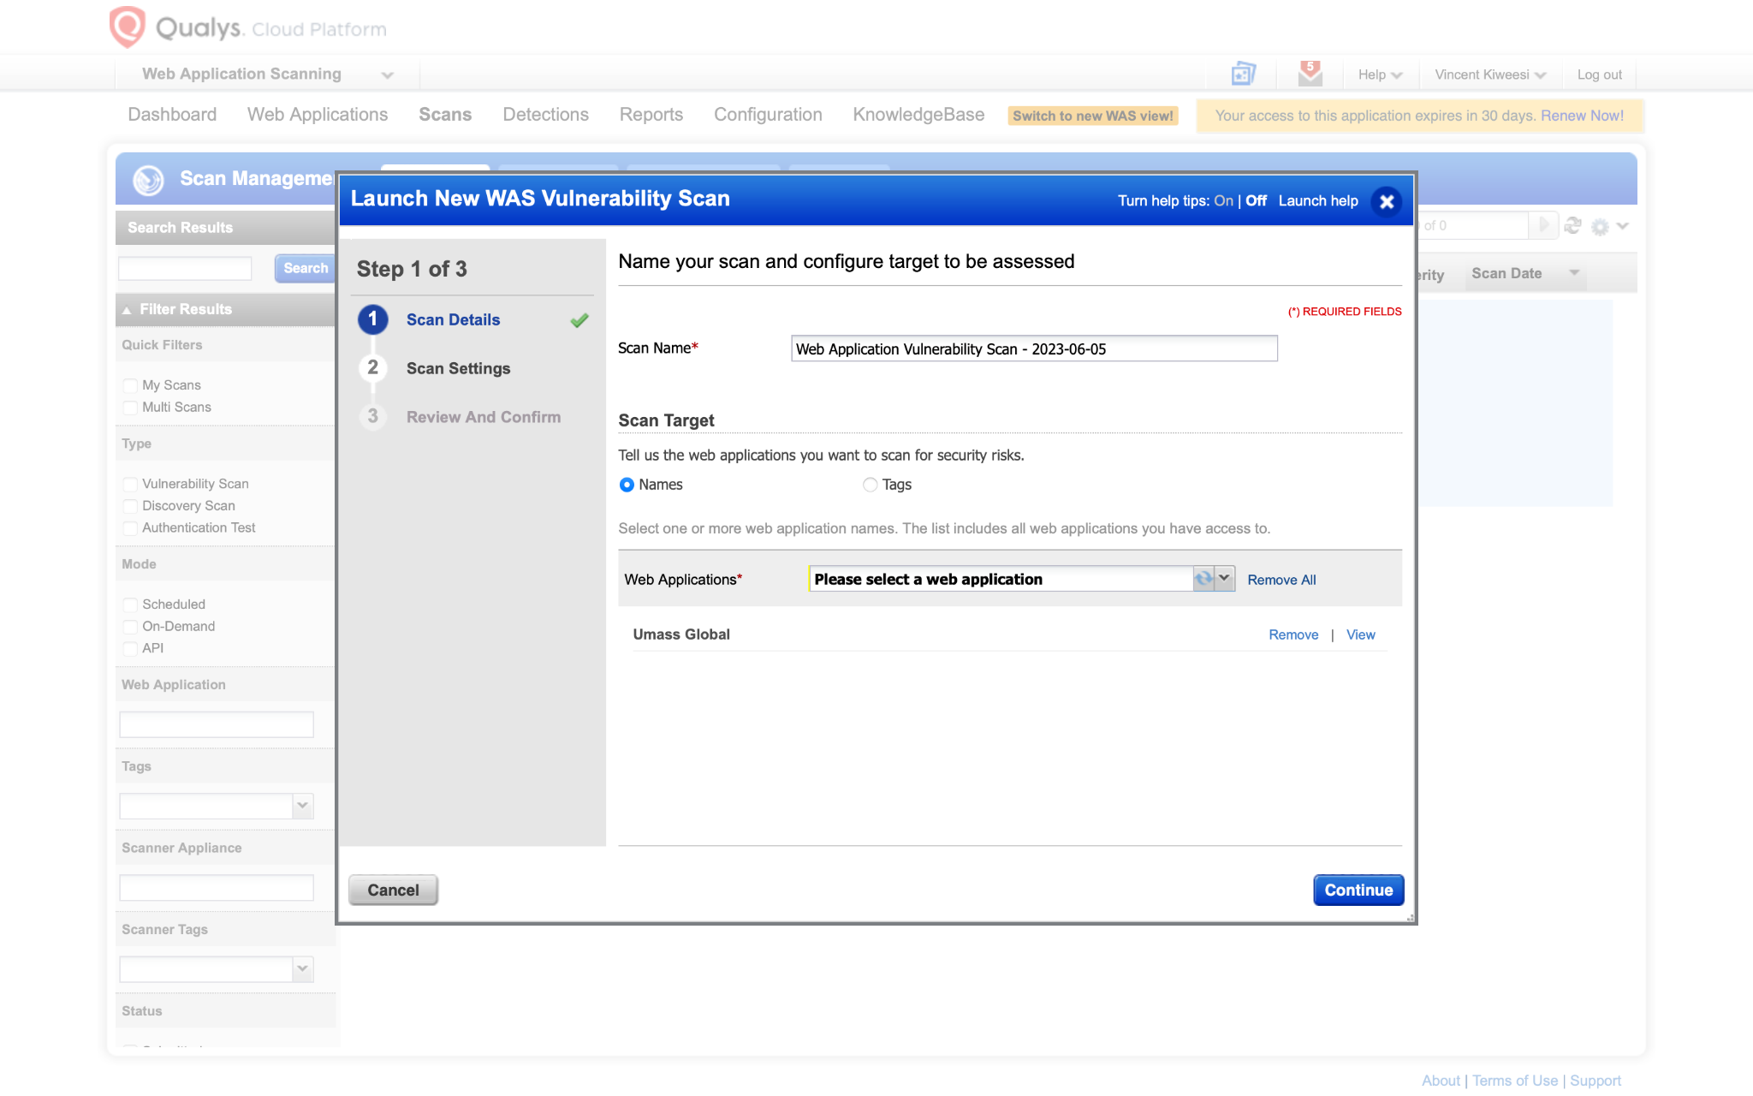

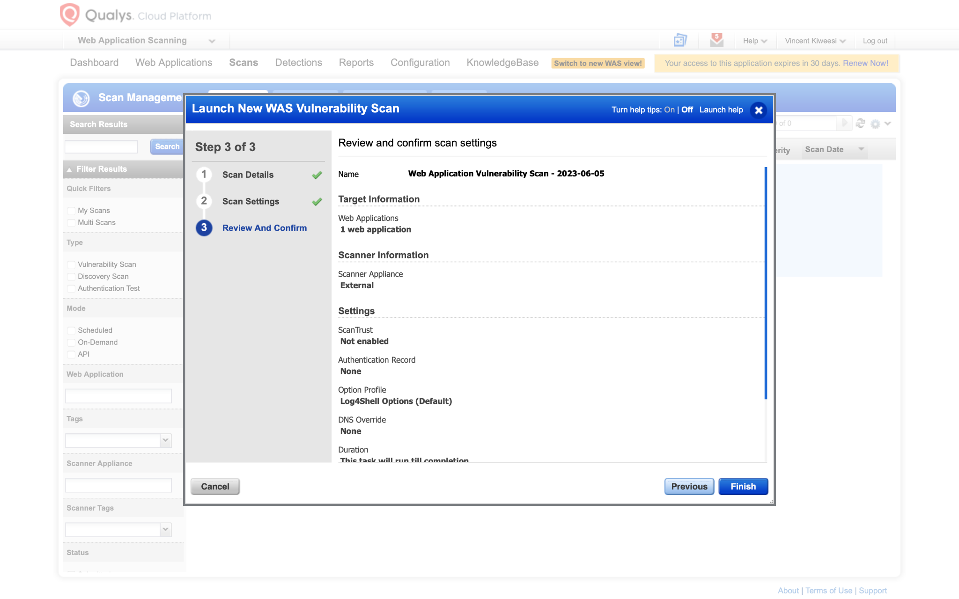

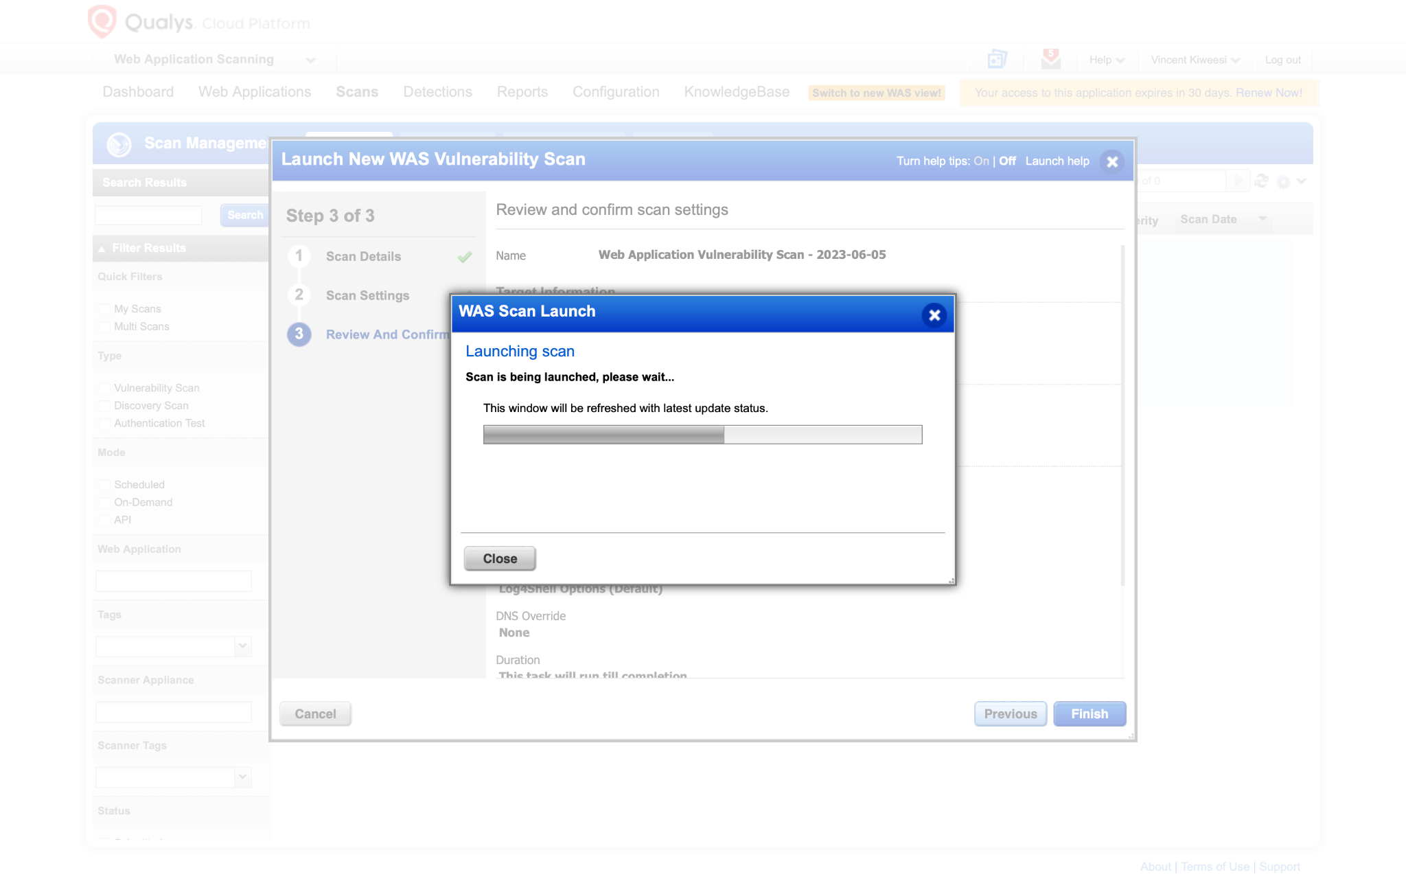

* The web application scanning dashboard reveals my results as shown in the image below.

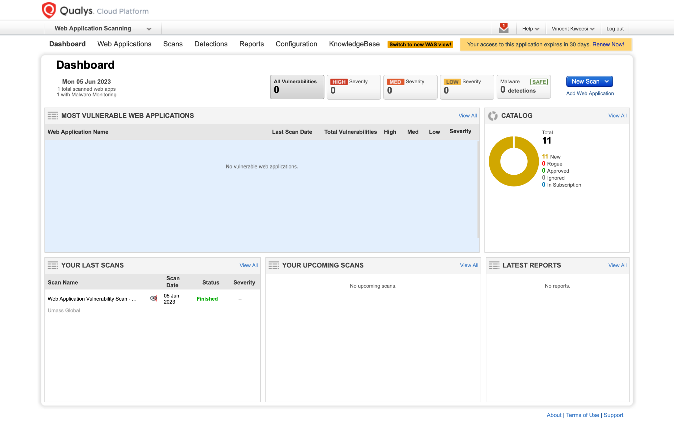

* Utilized the option to receive a summarized report in a registered Qualys email account.

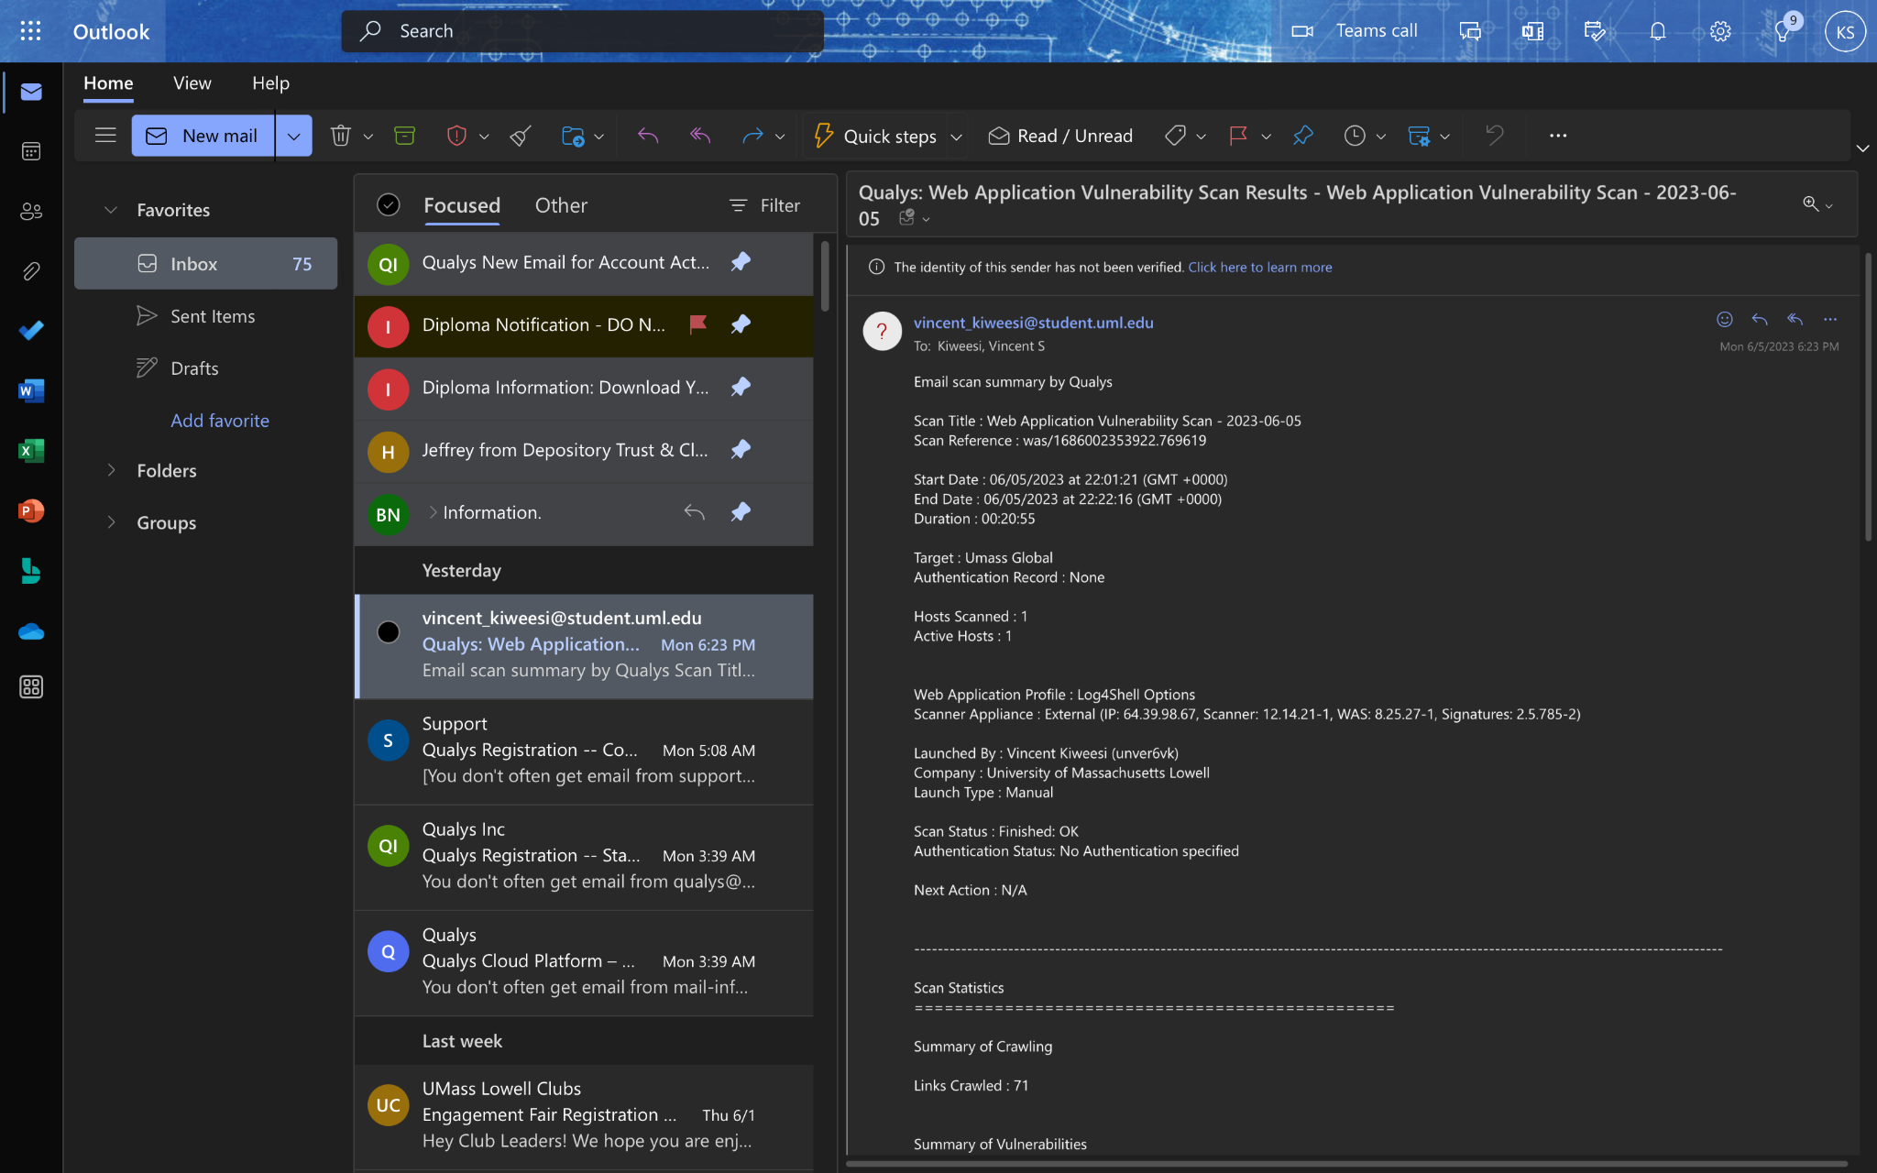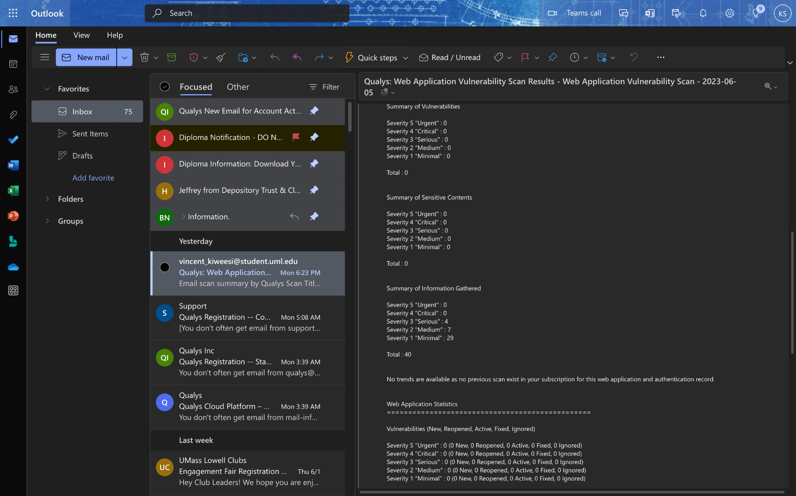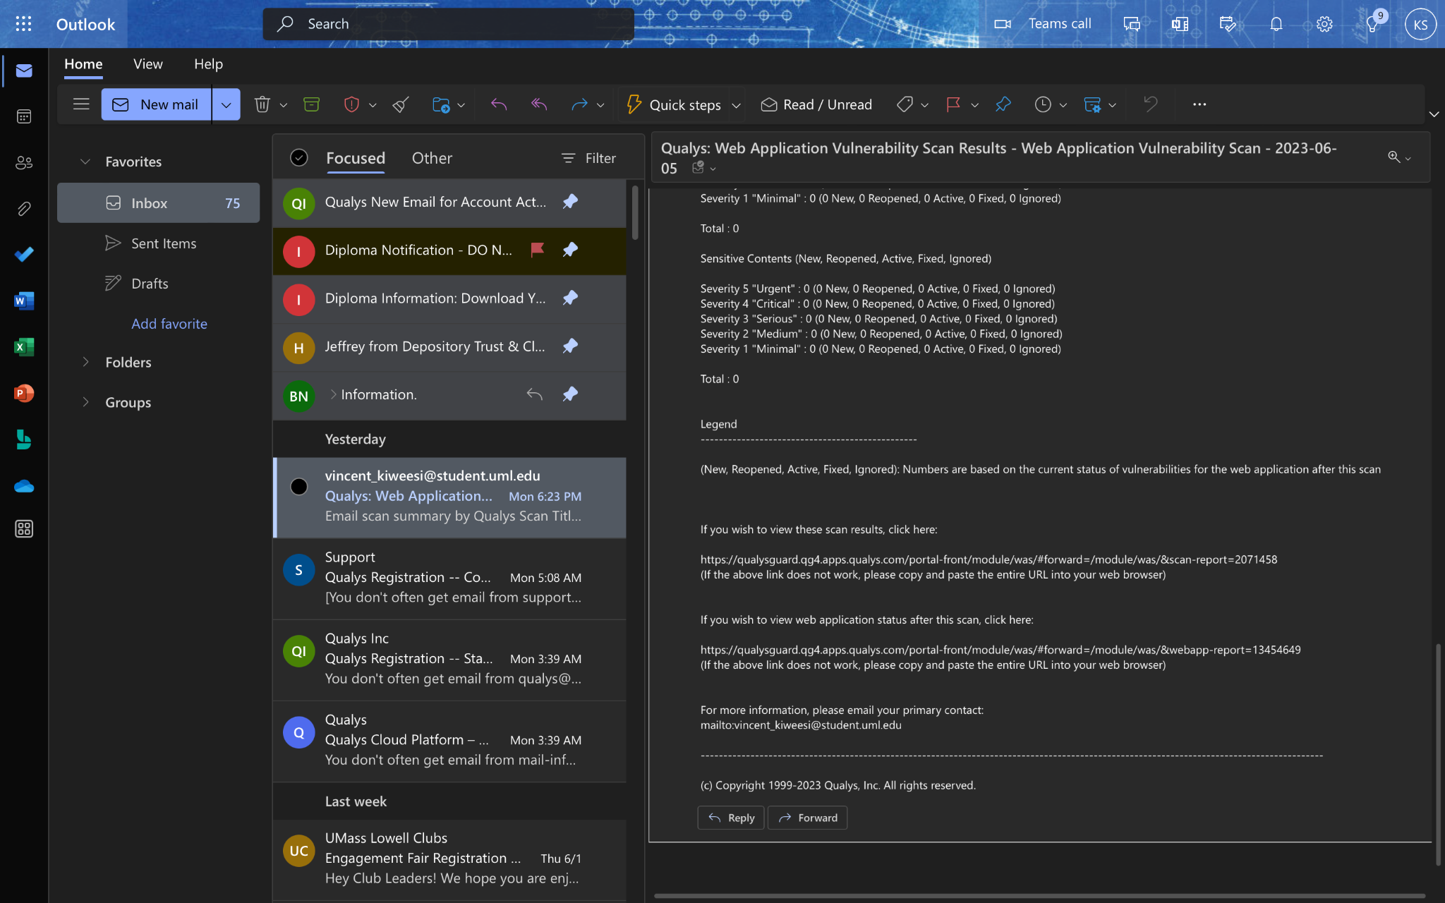

* The security weaknesses individually in the web application report are as shown below.

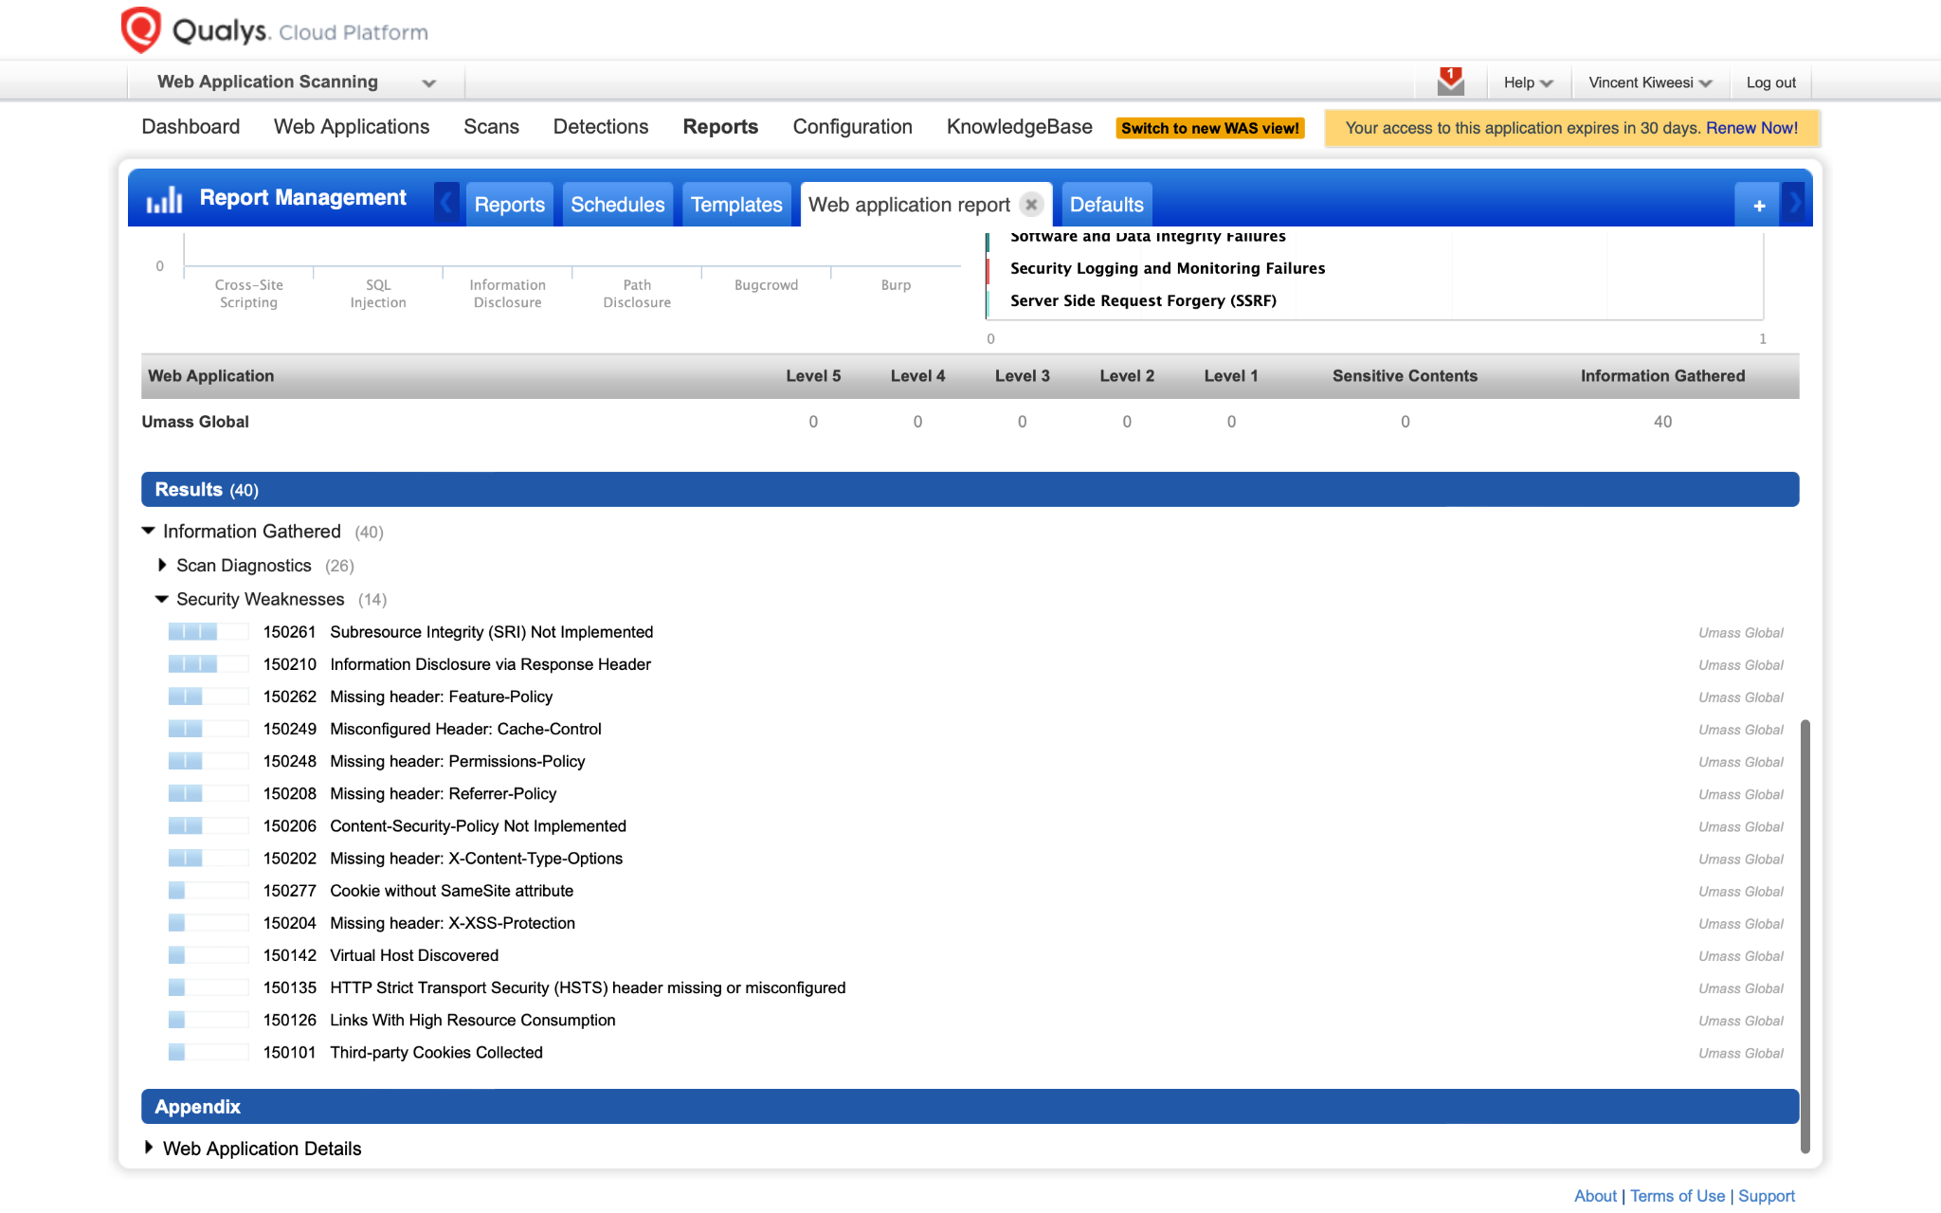

Finding vulnerabilities in a system or network requires the use of vulnerability scanning. Five tools Tenable Nessus, OpenVAS, Nmap, Nikto, and Qualys that can be used for vulnerability scanning have been covered in this page descrIPtion. Each of these technologies has its own advantages and disadvantages, and the best option will be determined by the organization's particular needs. Vulnerability scanning should only be one element of a comprehensive security program because no tool can guarantee 100% results.

Reference

20, S., 29, A., 31, M., & 22, M. (2021, June 6). *A brief introduction to the openvas Vulnerability Scanner*. Infosec Resources. https://resources.infosecinstitute.com/topic/a-brief-introduction-to-the-openvas-vulnerability-scanner/

Marasinghe, C. (2022, December 15). *Nikto: A practical website Vulnerability Scanner*. Medium. https://blog.bugzero.io/nikto-a-practical-website-vulnerability-scanner-b2005f496a7b

*Qualys VMDR - Vulnerability Management Tool*. Qualys. (n.d.).

https://www.qualys.com/apps/vulnerability-management-detection-response/#:~:text=A%20single%20solution%20for%20cybersecurity,on%20risk%20and%20business%20criticality.

Shivanandhan, M. (2020, October 2). *What is nmap and how to use it – a tutorial for the greatest scanning tool of all time*. freeCodeCamp.org. https://www.freecodecamp.org/news/what-is-nmap-and-how-to-use-it-a-tutorial-for-the-greatest-scanning-tool-of-all-time/

Tech2020. (2021, January 18). *What is nessus and how does it work? - ITPERFECTION - network security*. ITperfection. https://www.itperfection.com/network-security/network-monitoring/what-is-nessus-and-how-does-it-work-network-munitoring-vulnerabilit-scaning-security-data-windows-unix-linux/

Wear, Dr. S. (n.d.). *Web security testing with BURP suite*. Pluralsight. https://www.pluralsight.com/paths/web-security-testing-with-burp-suite#:~:text=Burp%20Suite%20is%20an%20integrated,finding%20and%20exploiting%20security%20vulnerabilities.